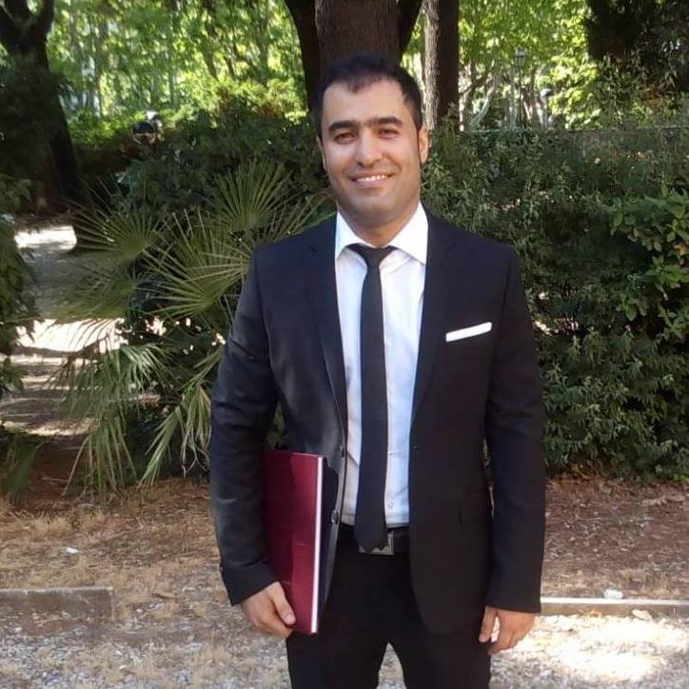

Ali Dehdarirad
Sapienza University of Rome

Dr. Ali Dehdarirad currently teaches American literature and culture at the Sapienza University of Rome where he obtained his Ph.D. in English-language Literatures. The title of his doctoral dissertation was “The Map is Not the Territory”: A Spatial Reading of Pynchon’s California Trilogy. He has published critical essays on the works of Thomas Pynchon, Don DeLillo, and Paul Auster. His main research interests include postmodernist and contemporary American Literature, Urban and Regional studies, Geocriticism, California Studies, Urban Humanities, and Ecocriticism.

