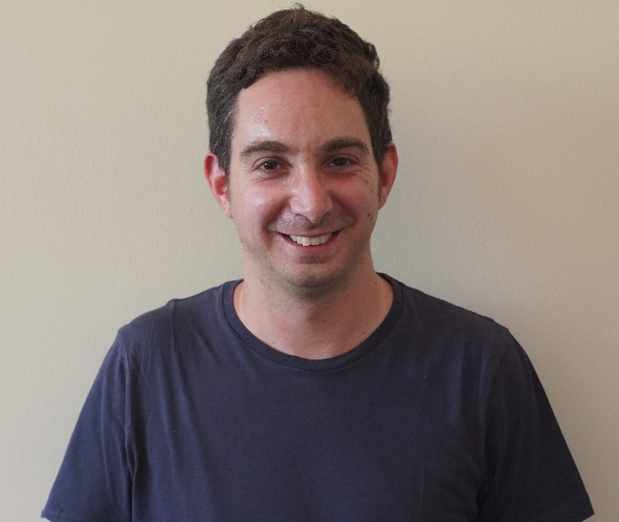

Dr. Adam Levin
University of the Witwatersrand, South Africa

Dr. Adam Levin is a postdoctoral research fellow at the African Centre for the Study of the United States which is based at the University of the Witwatersrand in South Africa. He is particularly interested in studies of historical trauma in the contexts of the Holocaust, African American history and post-apartheid South Africa. This builds on his PhD study at the University of Pretoria which concerned the representation of historical trauma within the context of literature focused on the Holocaust and South Africa’s Truth and Reconciliation Commission. His current research expands on aspects of this study as it reflects on representations of racial identities in the context of post-apartheid South African literature. His work has been featured in Holocaust Studies: A Journal of Culture and History and English Studies in Africa. His article in English Studies in Africa will be featured in an upcoming book collection entitled Cultures of Populism.

