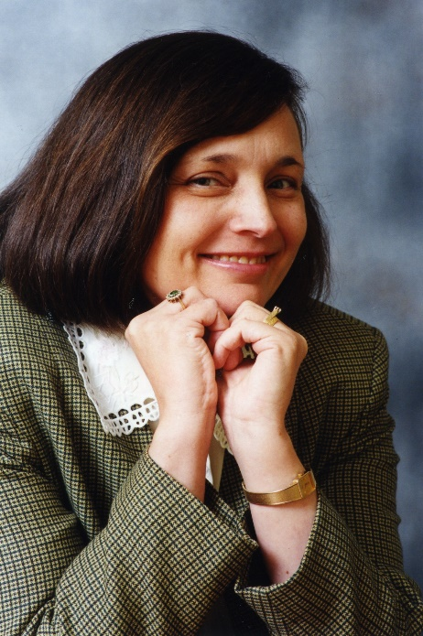

Prof. Merle Williams
University of the Witwatersrand, South Africa

Merle Williams is Professor Emerita of English at the University of the Witwatersrand in Johannesburg and a research associate of the recently established African Centre for the Study of the United States. She has served several terms both as head of the Department of English and as Assistant Dean for Graduate Studies in the Faculty of Humanities. Merle’s principal research interests range from the relations between literature and philosophy to Romantic poetry, nineteenth-century and modernist fiction, American writing and trauma theory. Substantial publications include Henry James and the Philosophical Novel: Being and Seeing (Cambridge University Press, reprinted 2009) and a critical text of The Awkward Age (approaching completion) for The Cambridge Edition of the Complete Fiction of Henry James. Hospitalities: Transitions and Transgressions, North and South (Routledge) appeared in December 2020. Another edited collection, Cultures of Populism: Institutions, Practices and Resistance, is forthcoming through Routledge in 2021. Merle has edited special journal issues for English Studies in Africa, the Journal of Literary Studies and Safundi: The Journal of South African and American Studies (all ISI-listed). She has held visiting research positions in Germany, Sweden and the United States, as well as teaching in the Melton adult education program coordinated by the Hebrew University in Jerusalem.

