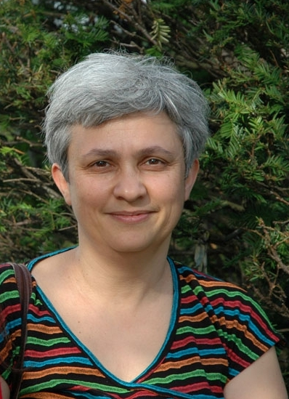

Dr. Donatella Izzo
University of Naples, “L’Orientale”

Dr. Donatella Izzo is professor of American Literature at Università di Napoli “L’Orientale.” Her research fields include American literature, American Studies, literary theory, and comparative literature. The author of four books and about a hundred essays in volumes and journals, and the editor or co-editor of 30 volumes and journal issues, she has published widely on Henry James (Portraying the Lady. Technologies of Gender in the Short Stories of Henry James, UP of Nebraska, 2001), Herman Melville, F. Scott Fitzgerald, and other 19th- and 20th-century American writers, as well as American studies as a disciplinary field, Asian American literature and theory, American TV series, the graphic novel in the US, cross-cultural literary rewritings, and the culture and politics of Hawai‘i. She is past President of AISNA, the Italian Association of American Studies, and of the international Henry James Society, and is one of the co-directors of the “Futures of American Studies” Institute directed by Donald Pease at Dartmouth College. A former co-editor-in.-chief of the international American Studies journal Ácoma, she is on the board of a number of other scholarly journals and series, both in Italy and in the USA. In 2012, with Giorgio Mariani, she launched OASIS—Orientale American Studies International School—, now in its third edition, a biennial one-week school held on the isle of Procida, near Naples, and aimed at creating a new venue for conversations among Americanists from the U.S.A., southern Europe, North Africa, and the Middle East.

