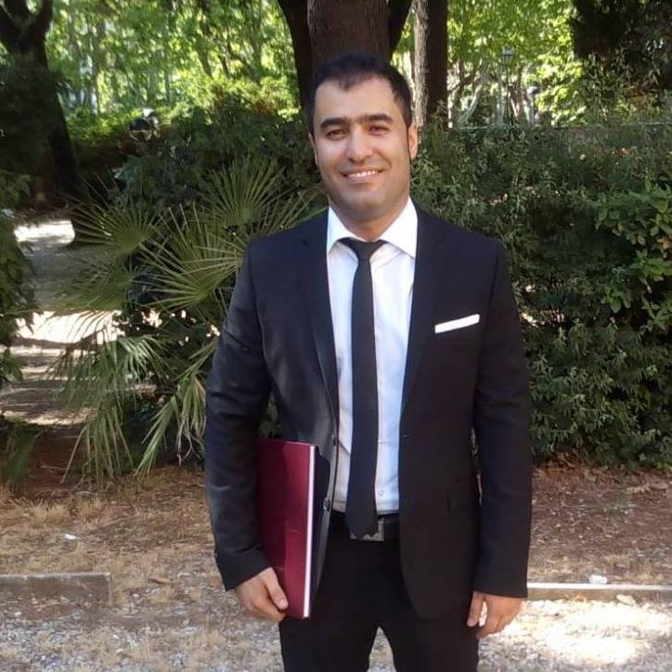

Ali Dehdarirad
Sapienza University of Rome

Dr. Ali Dehdarirad obtained a Ph.D. in English-language Literatures from Sapienza University of Rome, with a doctoral dissertation titled: “The Map is Not the Territory”: A Spatial Reading of Pynchon’s California Trilogy. He has published critical essays on the works of Thomas Pynchon, Don DeLillo, and Paul Auster. His main research interests include postmodernist and contemporary American literature, urban and regional studies, California space, geocriticism, literary geography, urban humanities, and GeoHumanities.

