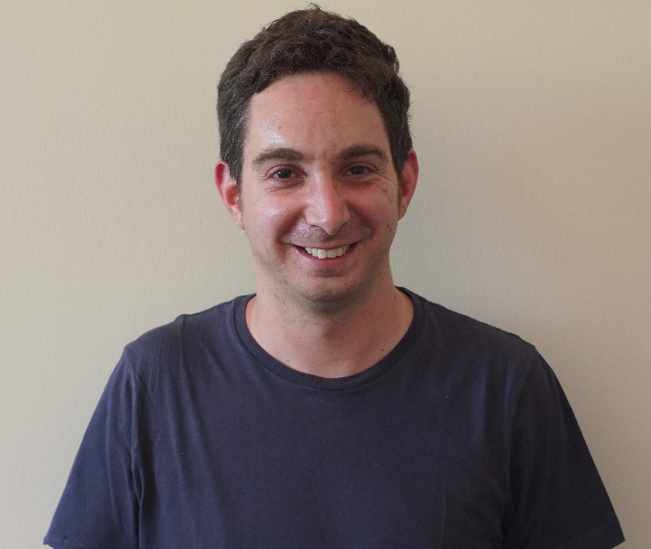

Dr. Adam Levin
University of the Witwatersrand, South Africa

Dr. Adam Levin is a research associate at the African Centre for the Study of the United States which is based at the University of the Witwatersrand in South Africa. He is particularly interested in studies of historical trauma in the contexts of the Holocaust, African American history and apartheid in South Africa. This builds on his PhD study at the University of Pretoria which concerned the representation of historical trauma within the context of literature focused on the Holocaust and South Africa’s Truth and Reconciliation Commission. His current research expands on aspects of this study as it considers issues of race, community and trauma in the contexts of Black Lives Matter literary narratives and post-apartheid South African literature. His work has been featured in Holocaust Studies: A Journal of Culture and History and English Studies in Africa.

